03 - Standard: Solving Equations Name: ____________________________________
Algebra 1 Final Exam Review
Solve the equations below. Make sure to show all work and check your solutions.
There is a combination of equations that contain the distributive property, rational coefficients, and absolute value.
1. $2\left(3x-1\right)=10$ 2. $3x-\left(2x-1\right)=-6$

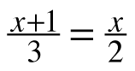
3. $\left|2x-3\right|=8$ 4.

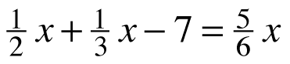
5. $-5\left(x-1\right)+2x=2$ 6.

7. $2x-5\left(x+4\right)=-2(x+3)$ 8. $\frac{1}{2}x-4+1=-3-\frac{1}{2}x$

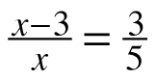
9. 10. $\left|3x+2\right|+4=12$

11. ${\left(x+2\right)}^{2}=x^{2}-x+6$ 12. $\left(x+3\right)\left(x-1\right)=x^{2}+2x+1$

13. $6+3\left|x – 2\right|=12$ 14. $x\left(x+2\right)=(\frac{1}{2}x+2)(x-3)$

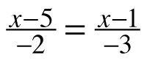
15. 16. $3-2\left|-3x+6\right|=-27$

17. $2x\left(x+1\right)=(2x+2)(x-1)$ 18. $\frac{2}{3}x-3=\frac{1}{2}x-7$

Solve the following equations for the specific variable.
19. Solve for y: 4x + 2y = 6 20. Solve for x: –5x + 4y = 10

21. Solve for w: $P=2l+2w$ 22. Solve for d: $t=\frac{d}{r}$

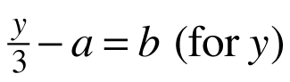
23. Solve for b: t = an + b (for b) 24.

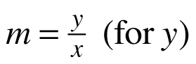
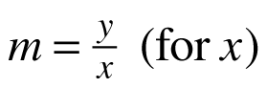
25. 26.

27. Determine if the statement below is always, sometimes, or never true. Justify your conclusion.
2(3 + 5x) = 6 + 5x

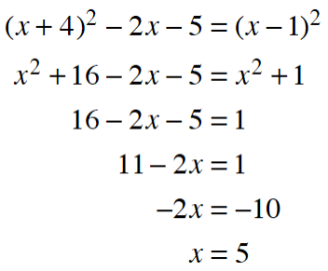
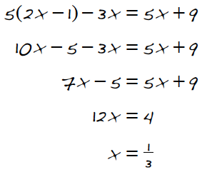
Determine the mistakes in the solutions below. Then correct the mistake and find the correct solution.
28. 29.

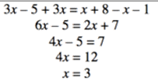
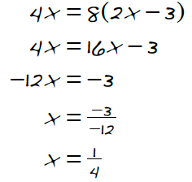
30. 31.

32. Rianna thinks that if a = b and if c = d, then a + c = b + d. Is she correct?

33. Create a multi-step equation that has the specified number of solutions, then solve each of your equations.
**Make sure to check with your teacher to make sure you set this one correctly because answers will vary**

a. No Solution b. Infinitely Many Solutions c. Two Solutions

